

Geophysical Research Letters

Supporting Information for

Effect of Nucleation Heterogeneity on Mineral Precipitation in Confined Environments
Fengchang Yang ^{1,2}, Dongshi Guan ^{1,2}, Vitalii Starchenko ³, Ke Yuan ³, Andrew G. Stack ³, Bowen Ling ^{1,2,*}

¹ Institute of Mechanics, Chinese Academy of Sciences, 15 Beisihuanxi Rd., Beijing 100190, China
² School of Engineering Science, University of Chinese Academy of Sciences, Beijing, 100049, China
³ Chemical Sciences Division, Oak Ridge National Laboratory, 1 Bethel Valley Rd., Oak Ridge, TN 37831, United States

Table of Contents
- Figure S1 to S5
- Text S1 to S2

Additional Supporting Information (Files uploaded separately)
Movie S1: 3D temporal evolution of solid phase in porous media (A=1E7)
Movie S2: 3D temporal evolution of solid phase in porous media (A=1E10)

Introduction
In this Support Information, more information on the validation of solver, deterministic precipitation and fixed flow rate simulation, 3D temporal evolution of solid phase in porous media were provided for the readers to better understand the numerical solver and results of this study.

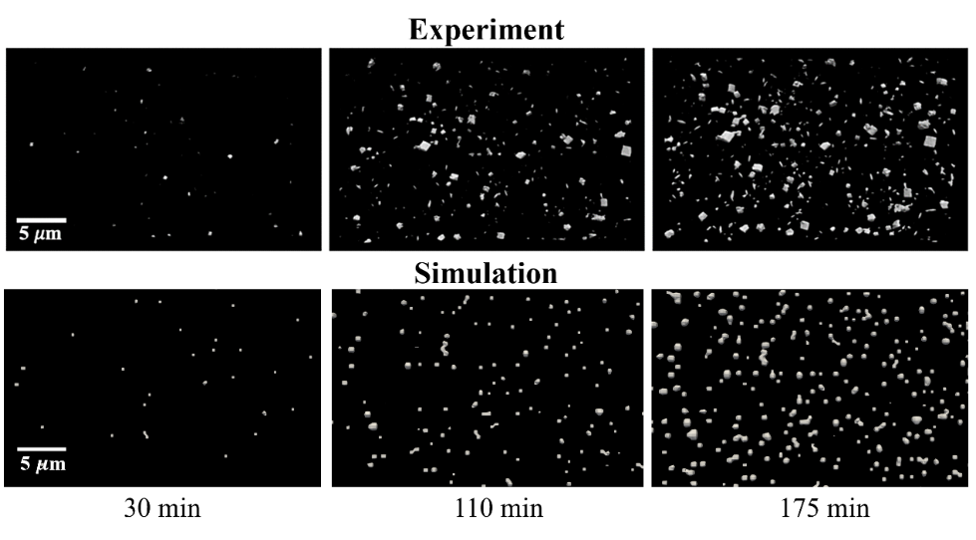

Figure S1. The comparison of temporal evolution of nuclei on tube wall between simulation and XnT experiment for barite in SI = 2.47 solution. The upper panel was reproduced from (Yuan et al, 2021) with permission, while the lower panel was obtained from the DBS simulation performed in this study. The original XnT data were processed and reconstructed using TomoPy and Fiji ImageJ.
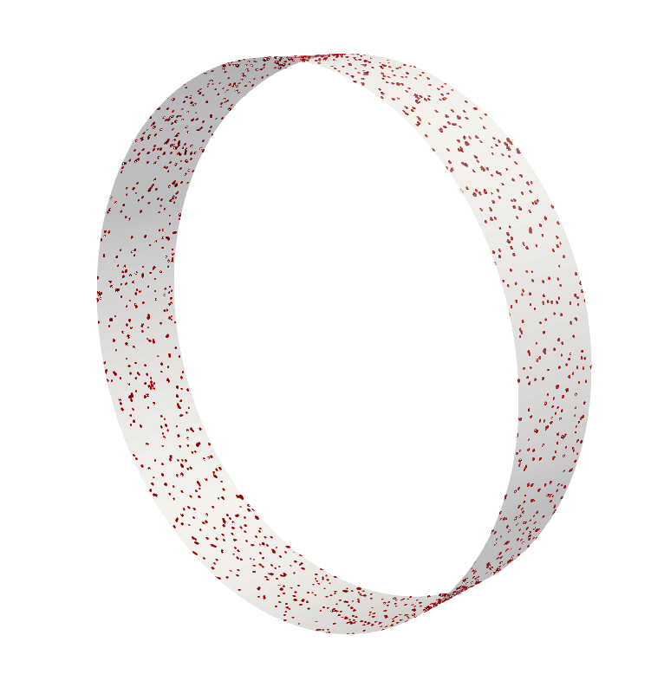

Figure S2. The 3D illustration of barite solid phase (red) distribution from simulations on a slice (20 $μm$ width) of capillary tube wall in SI = 2.47 solution at 110 min.

Text S1. Deterministic precipitation simulation
A deterministic precipitation simulation was performed with settings similar to the probabilistic precipitation case described in the main manuscript. However, contrast to the probabilistic precipitation setting, a very thin layer of mineral crystal (VoS=0.001) was evenly distributed next to the substrate to enable precipitation without probabilistic nucleation process. Hence, solid phase evolution on the surface was following Eqn. (1) from main manuscript, which started growth at the beginning of the simulation, unlike Eqn. (3). The results of the deterministic precipitation simulation could be found in Fig. 3 and Fig. S3. It was observed that the results of the deterministic precipitation simulation were more similar to the higher nucleation rate case in the probabilistic precipitation simulations. Hence, the permeability of the deterministic precipitation was higher than the estimation from lower nucleation rate case. This behavior is understandable as the probabilistic precipitation with an ultra-fast nucleation rate would trend to the deterministic precipitation behavior, which provided more evenly distributed solid phase on the substrate compared to the lower nucleation rate case.

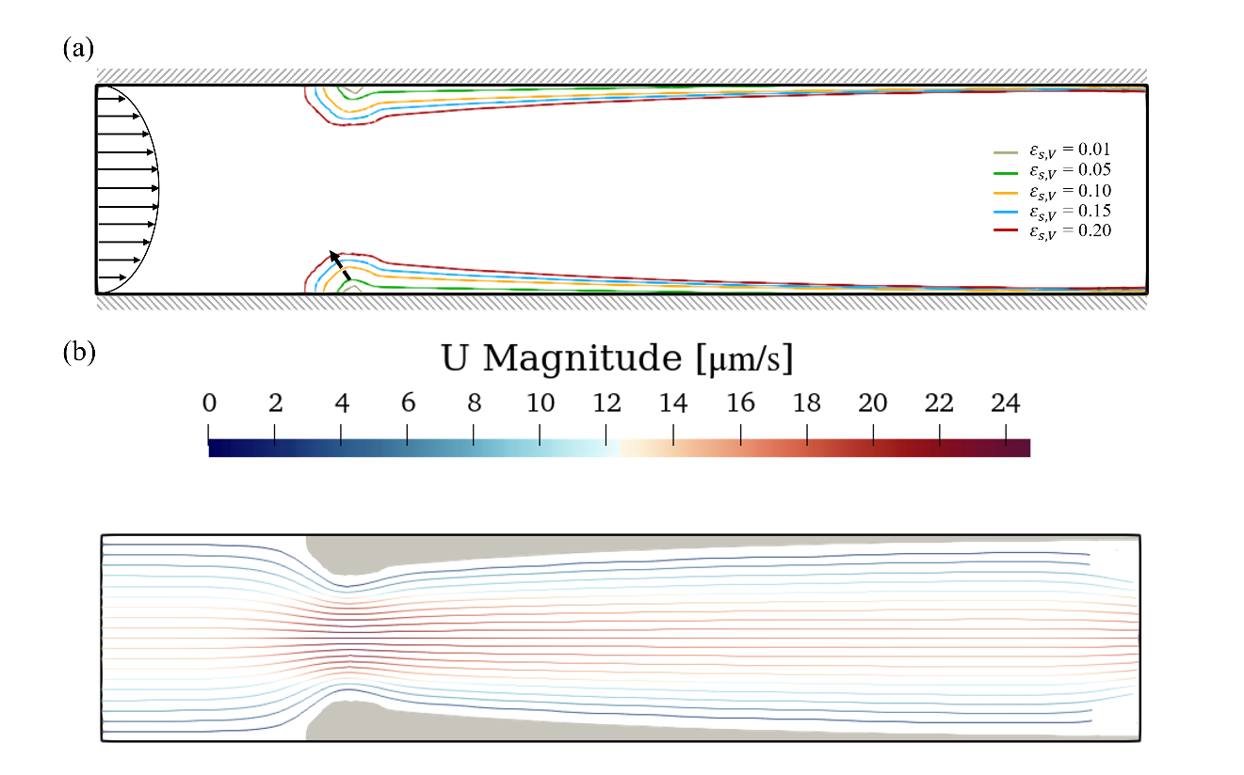

Figure S3. (a) Contour plot of the evolution history of precipitated solid phase for the deterministic simulation. (b) Streamline plot of fluid flow at $ε_{s,V}$=0.2.

Text S2. Fixed flow rate simulations
The fixed flow rate simulations were performed with similar settings as cases showed in Fig. 2a&b. However, instead of driven by an over pressure, the flow speed at the inlet was fixed as 50 $μ$m/s through the simulation to mimic the Pe~1 scenario. More detailed investigation on the impact of high-speed flow could also be valuable. However, it is out of the scope of this study, and will be explored in the future. Figure S4 shows the results of the fixed flow rate simulations. As the transport of species by advection was enhanced, the growth of solid phase located downstream was faster than the pressure-driven flow, in which the flow rate would gradually reduce by the narrowing of the channel. Hence, the permeability estimated in the fixed flow rate simulations at same solid volume fraction was slightly higher. In addition, the effect of Da number was also preserved in the fixed flow rate cases.

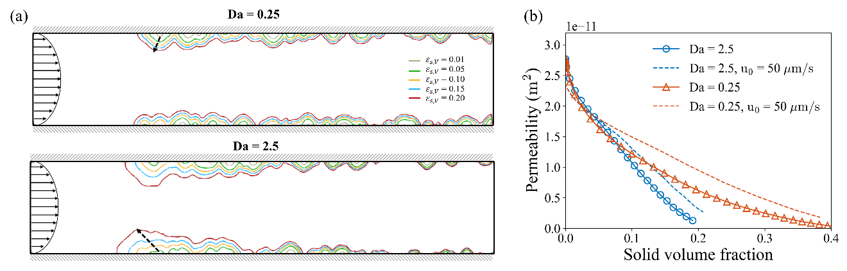

Figure S4. (a) Contour plot of the evolution history of precipitated solid phase for the fixed flow rate simulations at Da=0.25 and 2.5. (b) Permeability of the narrow pore as a function of the precipitated solid volume fraction for different Da numbers ($u_{0}$ represents fixed inlet flow speed).

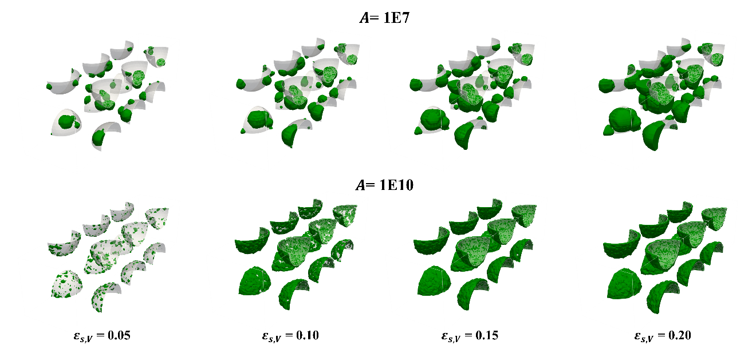

Figure S5. 3D solid phase distribution within the porous media for different nucleation rate (A=1E7 and 1E10 nuclei/m²/s cases) at different porosities ($ε_{s,V}$=0.05, 0.10, 0.15 and 0.2).

